Virtual Recipe Box

By Stephanie Wyckoff

**Introduction**

The idea for the Virtual Recipe Box app developed from two similar sources: my love of cooking and wanting to have my favorite recipes all in one easy to access place. Through the years I have acquired dozens of recipes which were then added to or pared down to make them as I want them. But whenever I wanted to make that recipe again, I would typically go back to the original and have to remember what it was that I had changed about it. The idea of having all my altered recipes in one place, in an easy to use platform was something that I wanted for a very long time and this project gave me the opportunity to create it for myself.

**Functionality**

In The Users Daily Life

The VRB has a simple interface that even my grandmother could utilize. We start with a home screen of five different food categories: Breakfast, Lunch, Dinner, Dessert, and Snacks. Each category is a button which when pressed will take the user to a home screen for that category. Here all the recipes associated with that category are listed by name. When the user clicks on the name button, the actual recipe is loaded and displayed for the user. There is even a comments section where the user can make notes about the recipe. For example, if my grandmother cooked the cauliflower mac n cheese recipe and decided to change the amount of cheese in it for her liking, she would need only make the note in the comments section and it would be forever there for her to reference whenever she decided to make the recipe again.

Operating System Level Functionality

*FileOutputStream*

Initially, the recipes were hard coded into strings on the MainActivity page of the app. This allows for the creation of the file using FileOutputStream, which converts the string and saves its contents to a text file. While this is the best way to meet the requirements for this project, I do not believe it to be the best practice overall. Android Studio has a feature called Assets. It is similar to the strings.xml except that instead of housing strings it houses whole text documents. It was possible for me to save a text file of the recipe to the Assets directory of my app in Android Studio. This would save on a lot of time and effort which went into ensuring that line breaks were hard coded to the appropriate places. The only potential downside to using the Assets is that they are inherently read-only. This is not an issue for my project as I determined that my files should not be editable. Additionally, the Assets are able to be called in a similar fashion to the hardcoded files stored using FileOutputStream. As the way Assets actually calls the text files is abstracted, I cannot say if this would have a been sufficient for the context of this course.

Another aspect of the app which used FileOutputStream was the creation and appending of the comment files for each recipe. Whenever the first comment is entered into the system by a new user, it creates the file in that instance. That file is housed in the same directory as the hardcoded recipe files <data/data/com.example.recipebox/files>. After this initial comment is entered, any and all subsequent comments simply append to the same file.

*FileInputStream*

After the initial setup of the app the recipe files were written to the users directory. From here, whenever a file needed to be written to the screen for the user to see, the API FileInputStream was utilized. This API is the match to the FileOutputStream and is very simple to utilize. First the file is read in, and then the file is converted to strings from characters and then it is displayed to the screen. This is also used to display the current list of comments in the comments text file, if it exists.

**Application Design**

The architecture utilized by Android Studio resembles the Model-View-Controller architecture which is quite popular today. The Controller here is the Class files. Each Layout requires its own unique Class file. This class file houses all the code which applies to how the layout view should function including names of buttons, what happens when those buttons are clicked. Most classes contained within this app are Controller Classes. These Classes are the backbone of the app. This is where the code is housed for buttons, displays, reading and writing text documents and changing screens via Intents. Android studio is a visual medium, and everything that is displayed to the user, is in the context of a Layout. This is the View portion. The View corresponds to the Layouts in Android Studio. Anything done in Android Studio requires a Layout and this Layout informs the system of what to display to the user. While every Layout (View) requires a Class (Controller) to tell it what to do and how to work, not every Class requires a Layout (View). The Model may be the hardest aspect to pin down. The model should be any Class which does not extend or implement an android class. As all of my classes extend and directly interact with the activities of other classes, this one does not apply. However I have built one other app which did utilize the Model; it is useful for getter and setter classes.

Controller Classes

In the Controller section of the architecture is located all of the Classes for this program. Below is a listing of all Classes and how they interact with Layouts, each other and their overall purpose in the program.

* *MainActivity* – This controls the initial layout of *activity_main*. Here the is where the hardcoded recipes are housed and where **FileOutputStream** is called to create the text files which will be called upon later in the program. Also, there are several Intents listed. Each Intent is associated with a button and tells the program when a specific button is pressed, the program should go from it current Layout to some other specified Layout.
* *breakfast* – This controls the *breakfast_view.xml* Layout. This Class is fairly simple, only housing two buttons each with an Intent. When the “French Toast” button is pressed, the Intent will take the user from the *breakfast_view.xml* to the *b_recipe_view.xml* Layout. If the user presses the “Back To Main” button, the Intent will take the user back to the *MainActivity* and *activity_main.xml*.
* *breakfast_recipe* – This controls the function of the *b_recipe_view.xml* Layout and is more robust than the breakfast Class. Initially we start with the Operating System level functionality of reading a file from memory. It begins with the code to read the text file in which the breakfast recipe of French Toast is stored utilizing the API **FileInputStream**. That file is read, converted from char to String and displayed to the user in the *b_recipe_view.xml* Layout. The comment file for this recipe is also read to the screen in the same fashion, if it exists. The user can input a new comment into the comment file. If this is the very first comment, the new file is created utilizing the API **FileOutputStream**. If it is not the first comment, then the comment file is simply appended again with **FileOutputStream**. There are three buttons for this class, each button corresponding to a different Intent. If the user clicks on “Save Comment” button, the comment entered to the screen will be added to the comment file or a new comment file will be created with this comment in it if one did not exist previously. It will then refresh the page, displaying the new comment in the comment section. If the user clicks on “Back To Breakfast”, the Intent will take the user back to the *breakfast_view.xml* Layout which is controlled by the *breakfast* Class. And finally, if the user clicks on the “Back To Main” button, the Intent will take the user back to the *activity_main.xml* Layout, which is controlled by *MainActivity* Class.
* *dessert* – This controls the *dessert_view.xml* Layout. This Class is fairly simple, only housing two buttons each with an Intent. When the “Chocolate Chip Banana Nut Muffins” button is pressed, the Intent will take the user from the *dessert_view* *.xml* to the *des_recipe_view.xml* Layout. If the user presses the “Back To Main” button, the Intent will take the user back to the *MainActivity* and *activity_main.xml*.
* *dessert_recipe* – This controls the function of the *des_recipe_view.xml* Layout and is more robust than the dessert Class. Initially we start with the Operating System level functionality of reading a file from memory. It begins with the code to read the text file in which the dessert recipe of Chocolate Chip Banana Nut Muffins is stored utilizing the API **FileInputStream**. That file is read, converted from char to String and displayed to the user in the *des_recipe_view.xml* Layout. The comment file for this recipe is also read to the screen in the same fashion, if it exists. The user can input a new comment into the comment file. If this is the very first comment, the new file is created utilizing the API **FileOutputStream**. If it is not the first comment, then the comment file is simply appended again with **FileOutputStream**. There are three buttons for this class, each button corresponding to a different Intent. If the user clicks on “Save Comment” button, the comment entered to the screen will be added to the comment file or a new comment file will be created with this comment in it if one did not exist previously. It will then refresh the page, displaying the new comment in the comment section. If the user clicks on “Back To Dessert”, the Intent will take the user back to the *dessert_view.xml* Layout which is controlled by the *dessert* Class. And finally, if the user clicks on the “Back To Main” button, the Intent will take the user back to the *activity_main.xml* Layout, which is controlled by *MainActivity* Class.
* *dinner* – This controls the *dinner_view.xml* Layout. This Class is fairly simple, only housing two buttons each with an Intent. When the “Cauliflower Mac n Cheese” button is pressed, the Intent will take the user from the *dinner_view.xml* to the *din_recipe_view.xml* Layout. If the user presses the “Back To Main” button, the Intent will take the user back to the *MainActivity* and *activity_main.xml*.
* *dinner_recipe* – This controls the function of the *din_recipe_view.xml* Layout and is more robust than the dinner Class. Initially we start with the Operating System level functionality of reading a file from memory. It begins with the code to read the text file in which the *dinner* recipe of Cauliflower Mac n Cheese is stored utilizing the API **FileInputStream**. That file is read, converted from char to String and displayed to the user in the *din_recipe_view.xml* Layout. The comment file for this recipe is also read to the screen in the same fashion, if it exists. The user can input a new comment into the comment file. If this is the very first comment, the new file is created utilizing the API **FileOutputStream**. If it is not the first comment, then the comment file is simply appended again with **FileOutputStream**. There are three buttons for this class, each button corresponding to a different Intent. If the user clicks on “Save Comment” button, the comment entered to the screen will be added to the comment file or a new comment file will be created with this comment in it if one did not exist previously. It will then refresh the page, displaying the new comment in the comment section. If the user clicks on “Back To Dinner”, the Intent will take the user back to the *dinner_view.xml* Layout which is controlled by the *dinner* Class. And finally, if the user clicks on the “Back To Main” button, the Intent will take the user back to the *activity_main.xml* Layout, which is controlled by *MainActivity* Class.
* *lunch* – This controls the *lunch_view.xml* Layout. This Class is fairly simple, only housing two buttons each with an Intent. When the “Apple Walnut Spinach Salad” button is pressed, the Intent will take the user from the *lunch_view.xml* to the *l_recipe_view.xml* Layout. If the user presses the “Back To Main” button, the Intent will take the user back to the *MainActivity* and *activity_main.xml*.
* *lunch_recipe* – This controls the function of the *l_recipe_view* Layout and is more robust than the lunch Class. Initially we start with the Operating System level functionality of reading a file from memory. It begins with the code to read the text file in which the *lunch* recipe of Apple Walnut Spinach Salad is stored utilizing the API **FileInputStream**. That file is read, converted from char to String and displayed to the user in the *l_recipe_view.xml* Layout. The comment file for this recipe is also read to the screen in the same fashion, if it exists. The user can input a new comment into the comment file. If this is the very first comment, the new file is created utilizing the API **FileOutputStream**. If it is not the first comment, then the comment file is simply appended again with **FileOutputStream**. There are three buttons for this class, each button corresponding to a different Intent. If the user clicks on “Save Comment” button, the comment entered to the screen will be added to the comment file or a new comment file will be created with this comment in it if one did not exist previously. It will then refresh the page, displaying the new comment in the comment section. If the user clicks on “Back To Lunch”, the Intent will take the user back to the *lunch_view.xml* Layout which is controlled by the *lunch* Class. And finally, if the user clicks on the “Back To Main” button, the Intent will take the user back to the *activity_main.xml* Layout, which is controlled by *MainActivity* Class.
* *snacks* – This controls the *snacks_view.xml* Layout. This Class is fairly simple, only housing two buttons each with an Intent. When the “Deviled Eggs” button is pressed, the Intent will take the user from the *snacks_view.xml* to the *s_recipe_view.xml* Layout. If the user presses the “Back To Main” button, the Intent will take the user back to the *MainActivity* and *activity_main.xml*.
* *snack_recipe* – This controls the function of the *s_recipe_view.xml* Layout and is more robust than the snacks Class. Initially we start with the Operating System level functionality of reading a file from memory. It begins with the code to read the text file in which the snack recipe of Deviled Eggs is stored utilizing the API **FileInputStream**. That file is read, converted from char to String and displayed to the user in the *s_recipe_view.xml* Layout. The comment file for this recipe is also read to the screen in the same fashion, if it exists. The user can input a new comment into the comment file. If this is the very first comment, the new file is created utilizing the API **FileOutputStream**. If it is not the first comment, then the comment file is simply appended again with **FileOutputStream**. There are three buttons for this class, each button corresponding to a different Intent. If the user clicks on “Save Comment” button, the comment entered to the screen will be added to the comment file or a new comment file will be created with this comment in it if one did not exist previously. It will then refresh the page, displaying the new comment in the comment section. If the user clicks on “Back To Snacks”, the Intent will take the user back to the *snacks_view.xml* Layout which is controlled by the *snacks* Class. And finally, if the user clicks on the “Back To Main” button, the Intent will take the user back to the *activity_main.xml* Layout, which is controlled by *MainActivity* Class.

View – **User Interface**

In the View section of the architecture is located all of the XML Layouts for this program. This is the User Interface. Below is a listing of all XML Layouts and how they interact with Layouts, each other and their overall purpose in the program.

* *activity_main.xml* – This is the layout of the first page we see in the app. This Layout has a title card labeled “RecipeBox” and five labeled buttons: “Breakfast”, “Lunch”, “Dinner”, “Dessert”, and “Snacks”. Each of these buttons is aligned with an Intent in the *MainActivity.xml* Class linking them to a Layout listing all of their respective types of recipes.

*activity_main.xml*

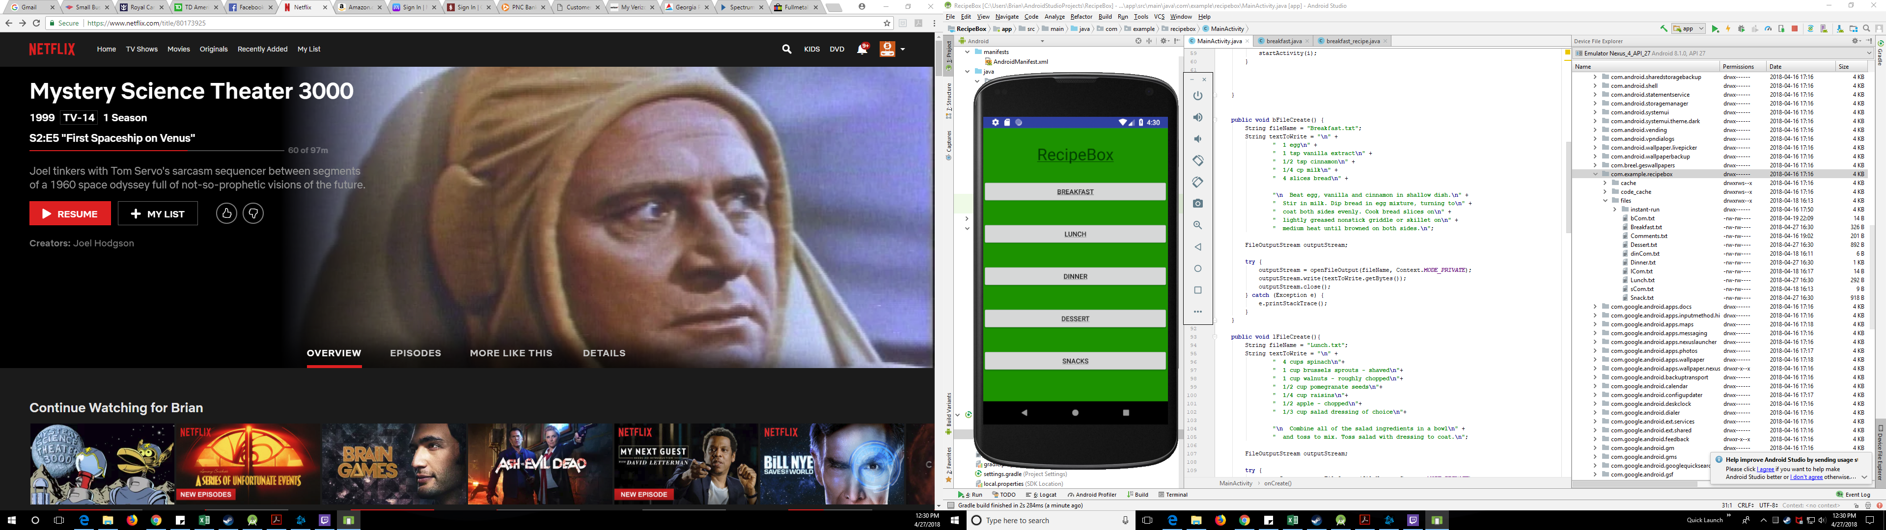

* *b_recipe_view.xml* – This layout is the heart of the app, this is where the recipe file is displayed for the user, where the comments file is displayed for the user, and where comments can be added to the comments file. Initially there is a title card, followed by the recipe file. The recipe file is housed in a scrollable text box. Below this is a solid black line which separates the recipe from the Comments section. Next is the Comments section where the comments file is displayed. This is also housed in a scrollable text box. Below this is a solid black line which separates the Comments from the New Comments section. Next there is a writable text field where the user can input new comments. This is followed by three labeled buttons: “Save Comment”, “Back To Breakfast”, and “Back To Main”.
* *breakfast_view.xml* – This is the layout of the list of all breakfast recipes. Each recipe is listed as a labeled button. There is currently only one breakfast recipe listed, which can be accessed by clicking on the button labeled “French Toast”. When this button is pressed, the Intent associated with it in the *breakfast* Class takes the user to the *b_recipe_view.xml* Layout. The other button here, “Back to Main”, when clicked will activate the other Intent in the *breakfast* Class which take the user back to *activity_main.xml* which is controlled by *MainActivity*.

*breakfast_view.xml -- b_recipe_view.xml -- b_recipe_view.xml with new comment*

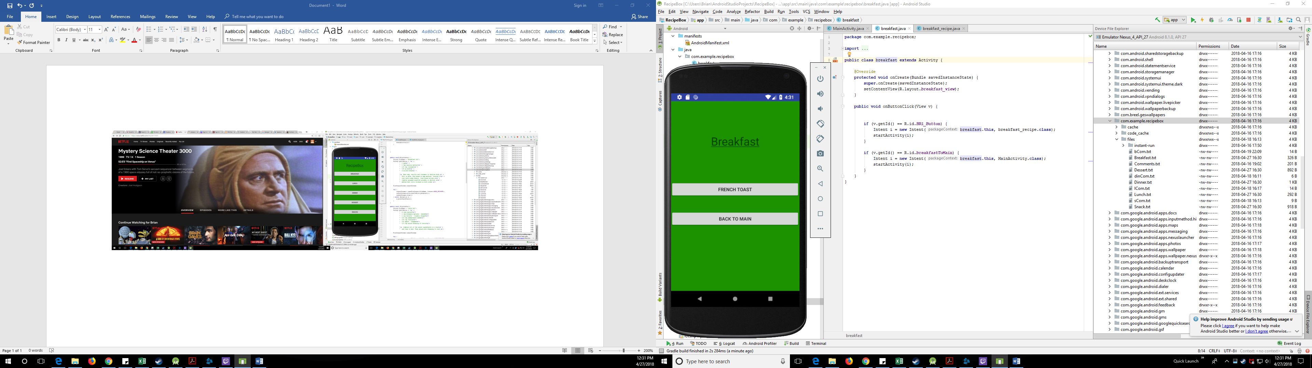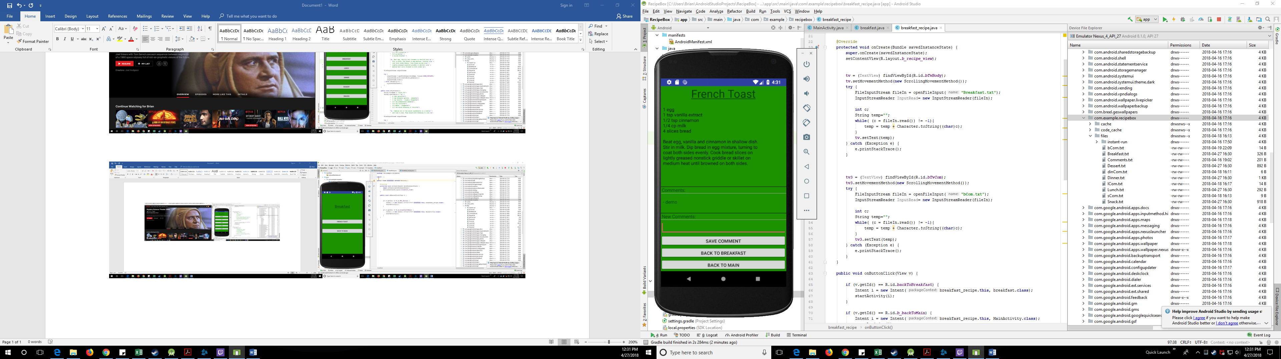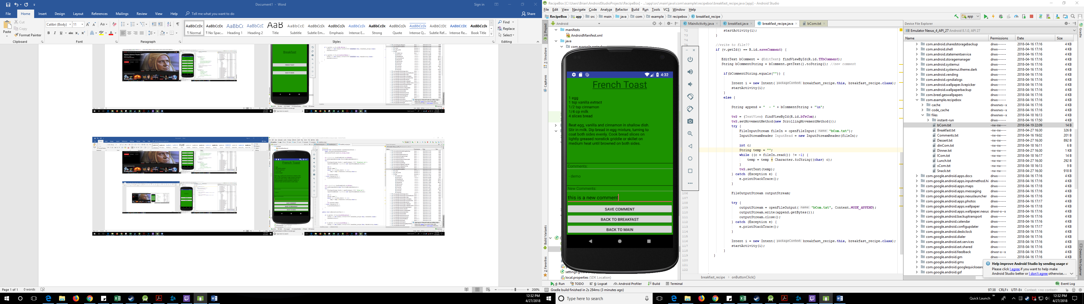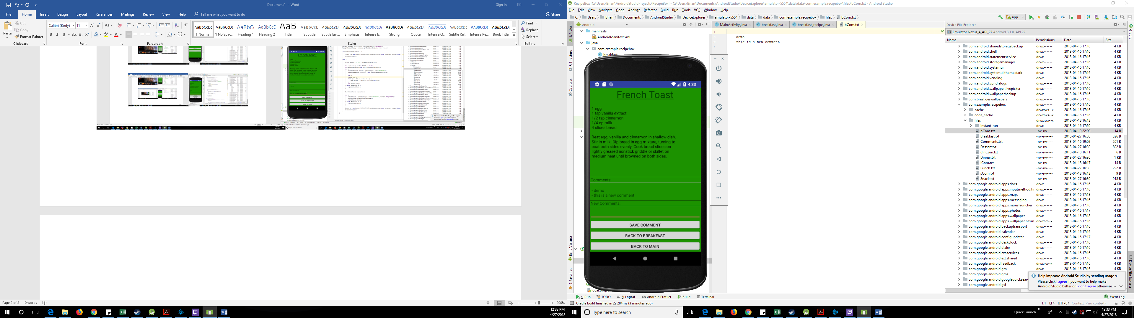

* *des_recipe_view.xml* – This layout is the heart of the app, this is where the recipe file is displayed for the user, where the comments file is displayed for the user, and where comments can be added to the comments file. Initially there is a title card, followed by the recipe file. The recipe file is housed in a scrollable text box. Below this is a solid black line which separates the recipe from the Comments section. Next is the Comments section where the comments file is displayed. This is also housed in a scrollable text box. Below this is a solid black line which separates the Comments from the New Comments section. Next there is a writable text field where the user can input new comments. This is followed by three labeled buttons: “Save Comment”, “Back To Dessert”, and “Back To Main”.
* *dessert_view.xml* – This is the layout of the list of all dessert recipes. Each recipe is listed as a labeled button. There is currently only one dessert recipe listed, which can be accessed by clicking on the button labeled “Chocolate Chip Banana Nut Muffins”. When this button is pressed, the Intent associated with it in the *dessert* Class takes the user to the *des_recipe_view.xml* Layout. The other button here, “Back to Main”, when clicked will activate the other Intent in the *dessert* Class which take the user back to *activity_main.xml* which is controlled by *MainActivity*.

*dessert_view.xml -- des_recipe_view.xml*

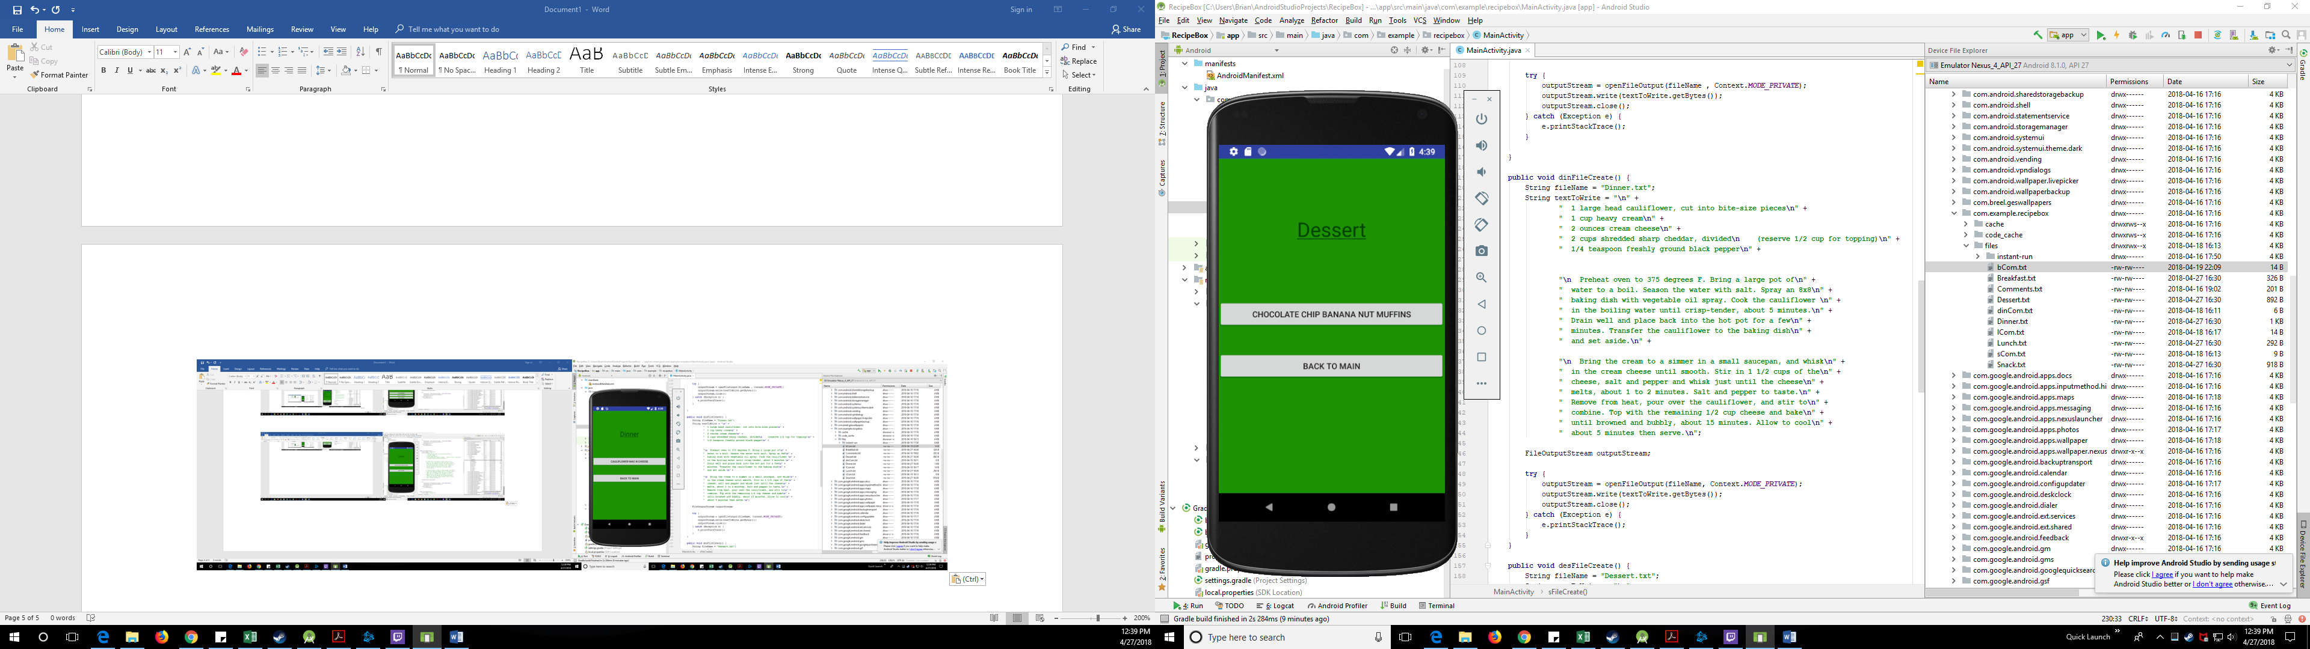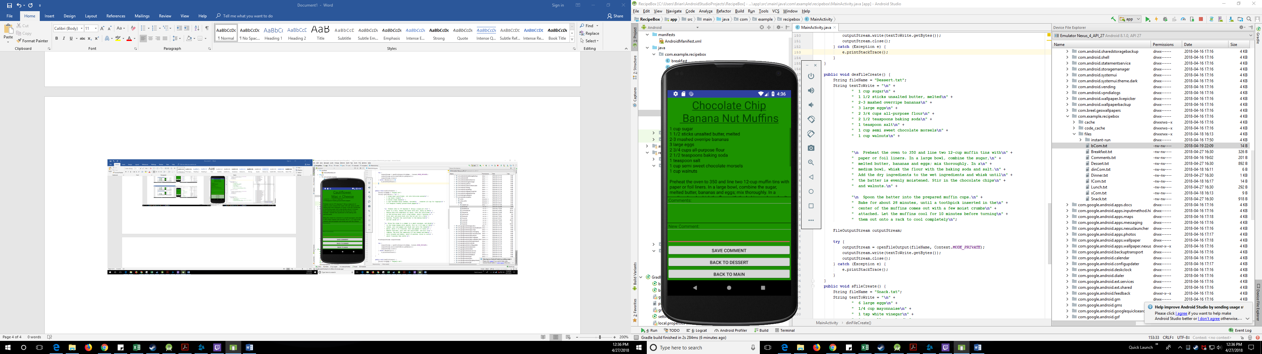

* *din_recipe_view.xml* – This layout is the heart of the app, this is where the recipe file is displayed for the user, where the comments file is displayed for the user, and where comments can be added to the comments file. Initially there is a tile card, followed by the recipe file. The recipe file is housed in a scrollable text box. Below this is a solid black line which separates the recipe from the Comments section. Next is the Comments section where the comments file is displayed. This is also housed in a scrollable text box. Below this is a solid black line which separates the Comments from the New Comments section. Next there is a writable text field where the user can input new comments. This is followed by three labeled buttons: “Save Comment”, “Back To Dinner”, and “Back To Main”.
* *dinner_view.xml* – This is the layout of the list of all dinner recipes. Each recipe is listed as a labeled button. There is currently only one dinner recipe listed, which can be accessed by clicking on the button labeled “Cauliflower Mac n Cheese”. When this button is pressed, the Intent associated with it in the *dinner* Class takes the user to the *din_recipe_view.xml* Layout. The other button here, “Back to Main”, when clicked will activate the other Intent in the *dinner* Class which take the user back to *activity_main.xml* which is controlled by *MainActivity*.

*dinner_view.xml -- din_recipe_view.xml*

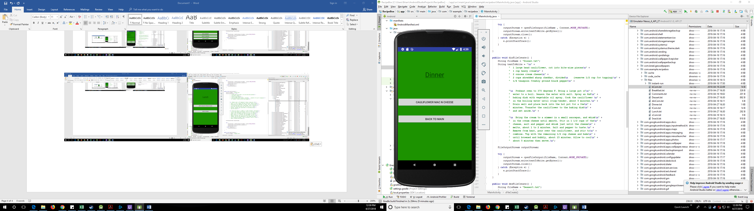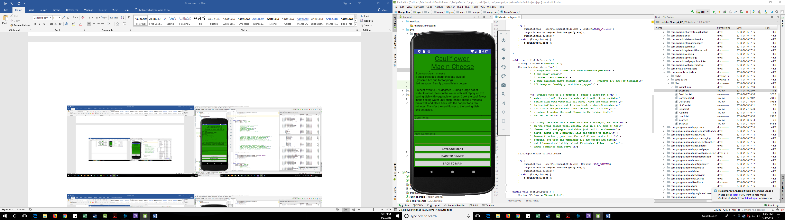

* *l_recipe_view.xml* – This layout is the heart of the app, this is where the recipe file is displayed for the user, where the comments file is displayed for the user, and where comments can be added to the comments file. Initially there is a tile card, followed by the recipe file. The recipe file is housed in a scrollable text box. Below this is a solid black line which separates the recipe from the Comments section. Next is the Comments section where the comments file is displayed. This is also housed in a scrollable text box. Below this is a solid black line which separates the Comments from the New Comments section. Next there is a writable text field where the user can input new comments. This is followed by three labeled buttons: “Save Comment”, “Back To Lunch”, and “Back To Main”.
* *lunch_view.xml* – This is the layout of the list of all lunch recipes. Each recipe is listed as a labeled button. There is currently only one lunch recipe listed, which can be accessed by clicking on the button labeled “Apple Walnut Spinach Salad”. When this button is pressed, the Intent associated with it in the *lunch* Class takes the user to the *l_recipe_view.xml* Layout. The other button here, “Back to Main”, when clicked will activate the other Intent in the *lunch* Class which take the user back to *activity_main.xml* which is controlled by *MainActivity*.

*lunch_view.xml -- l_recipe_view.xml*

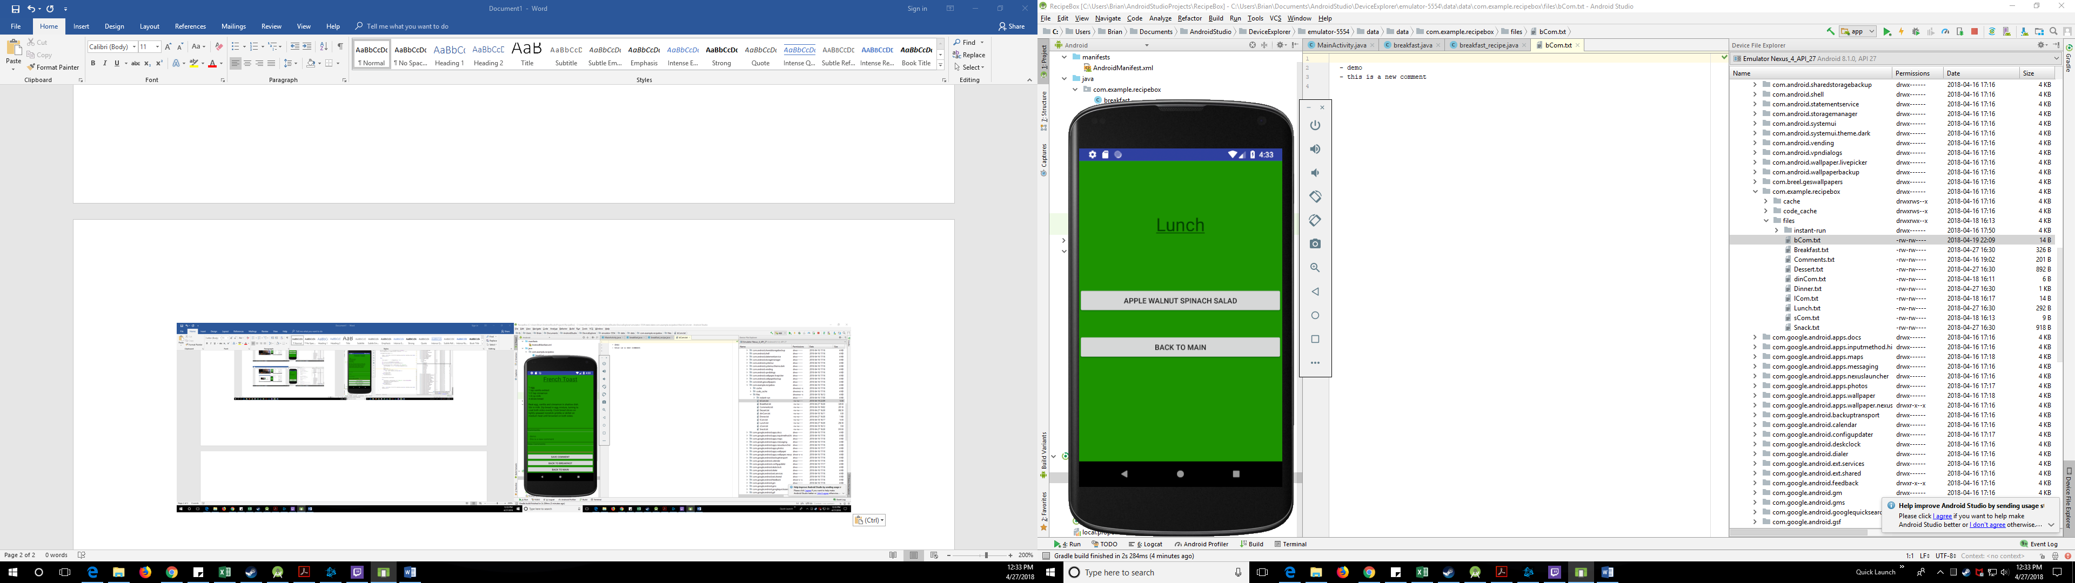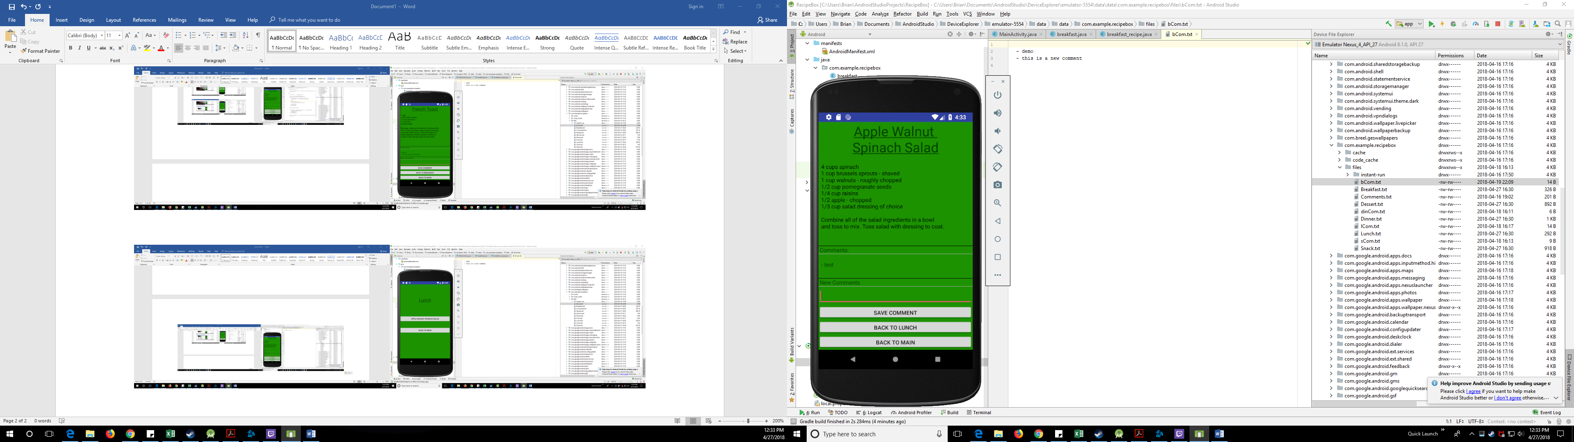

* *s_recipe_view.xml* – This layout is the heart of the app, this is where the recipe file is displayed for the user, where the comments file is displayed for the user, and where comments can be added to the comments file. Initially there is a tile card, followed by the recipe file. The recipe file is housed in a scrollable text box. Below this is a solid black line which separates the recipe from the Comments section. Next is the Comments section where the comments file is displayed. This is also housed in a scrollable text box. Below this is a solid black line which separates the Comments from the New Comments section. Next there is a writable text field where the user can input new comments. This is followed by three labeled buttons: “Save Comment”, “Back To Snacks”, and “Back To Main”.
* *snacks_view.xml* – This is the layout of the list of all snack recipes. Each recipe is listed as a labeled button. There is currently only one snack recipe listed, which can be accessed by clicking on the button labeled “Deviled Eggs”. When this button is pressed, the Intent associated with it in the *snacks* Class takes the user to the *s_recipe_view.xml* Layout. The other button here, “Back to Main”, when clicked will activate the other Intent in the *snacks* Class which take the user back to *activity_main.xml* which is controlled by *MainActivity*.

*snacks_view.xml -- s_recipe_view.xml*

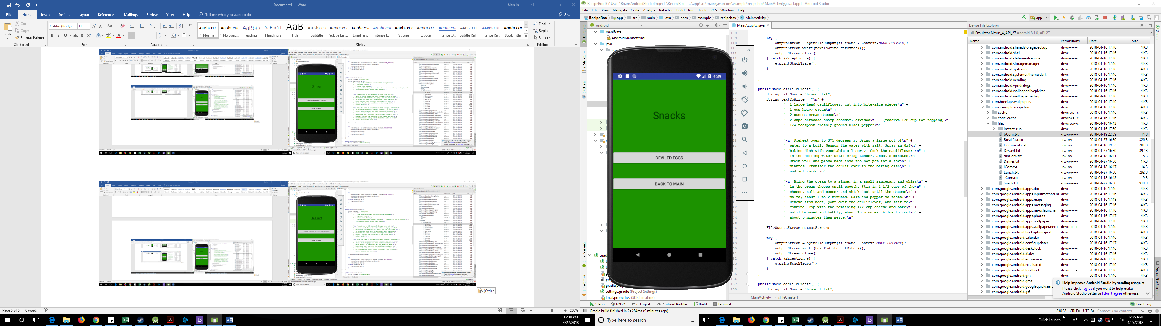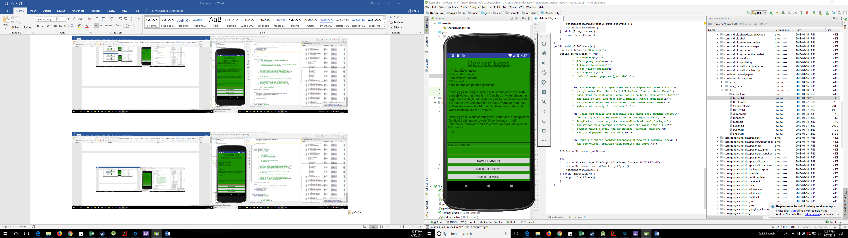

**Source Code**

Java Code

*MainActivity.java*

package com.example.recipebox;

import android.content.Context;

import android.content.Intent;

import android.support.v7.app.AppCompatActivity;

import android.os.Bundle;

import android.view.View;

import android.widget.EditText;

import android.widget.TextView;

import java.io.File;

import java.io.FileOutputStream;

public class MainActivity extends AppCompatActivity {

@Override

protected void onCreate(Bundle savedInstanceState) {

super.onCreate(savedInstanceState);

setContentView(R.layout.activity_main);

bFileCreate();

lFileCreate();

dinFileCreate();

desFileCreate();

sFileCreate();

}

public void onButtonClick(View v) {

if (v.getId() == R.id.breakfastButton) {

Intent i = new Intent(MainActivity.this, breakfast.class);

startActivity(i);

}

if (v.getId() == R.id.lunchButton) {

Intent i = new Intent(MainActivity.this, lunch.class);

startActivity(i);

}

if (v.getId() == R.id.dinnerButton) {

Intent i = new Intent(MainActivity.this, dinner.class);

startActivity(i);

}

if (v.getId() == R.id.dessertButton) {

Intent i = new Intent(MainActivity.this, dessert.class);

startActivity(i);

}

if (v.getId() == R.id.snackButton) {

Intent i = new Intent(MainActivity.this, snacks.class);

startActivity(i);

}

}

public void bFileCreate() {

String fileName = "Breakfast.txt";

String textToWrite = "\n" +

" 1 egg\n" +

" 1 tsp vanilla extract\n" +

" 1/2 tsp cinnamon\n" +

" 1/4 cp milk\n" +

" 4 slices bread\n" +

"\n Beat egg, vanilla and cinnamon in shallow dish.\n" +

" Stir in milk. Dip bread in egg mixture, turning to\n" +

" coat both sides evenly. Cook bread slices on\n" +

" lightly greased nonstick griddle or skillet on\n" +

" medium heat until browned on both sides.\n";

FileOutputStream outputStream;

try {

outputStream = openFileOutput(fileName, Context.MODE_PRIVATE);

outputStream.write(textToWrite.getBytes());

outputStream.close();

} catch (Exception e) {

e.printStackTrace();

}

}

public void lFileCreate(){

String fileName = "Lunch.txt";

String textToWrite = "\n" +

" 4 cups spinach\n"+

" 1 cup brussels sprouts - shaved\n"+

" 1 cup walnuts - roughly chopped\n"+

" 1/2 cup pomegranate seeds\n"+

" 1/4 cup raisins\n"+

" 1/2 apple - chopped\n"+

" 1/3 cup salad dressing of choice\n"+

"\n Combine all of the salad ingredients in a bowl\n" +

" and toss to mix. Toss salad with dressing to coat.\n";

FileOutputStream outputStream;

try {

outputStream = openFileOutput(fileName , Context.MODE_PRIVATE);

outputStream.write(textToWrite.getBytes());

outputStream.close();

} catch (Exception e) {

e.printStackTrace();

}

}

public void dinFileCreate() {

String fileName = "Dinner.txt";

String textToWrite = "\n" +

" 1 large head cauliflower, cut into bite-size pieces\n" +

" 1 cup heavy cream\n" +

" 2 ounces cream cheese\n" +

" 2 cups shredded sharp cheddar, divided\n (reserve 1/2 cup for topping)\n" +

" 1/4 teaspoon freshly ground black pepper\n" +

"\n Preheat oven to 375 degrees F. Bring a large pot of\n" +

" water to a boil. Season the water with salt. Spray an 8x8\n" +

" baking dish with vegetable oil spray. Cook the cauliflower \n" +

" in the boiling water until crisp-tender, about 5 minutes.\n" +

" Drain well and place back into the hot pot for a few\n" +

" minutes. Transfer the cauliflower to the baking dish\n" +

" and set aside.\n" +

"\n Bring the cream to a simmer in a small saucepan, and whisk\n" +

" in the cream cheese until smooth. Stir in 1 1/2 cups of the\n" +

" cheese, salt and pepper and whisk just until the cheese\n" +

" melts, about 1 to 2 minutes. Salt and pepper to taste.\n" +

" Remove from heat, pour over the cauliflower, and stir to\n" +

" combine. Top with the remaining 1/2 cup cheese and bake\n" +

" until browned and bubbly, about 15 minutes. Allow to cool\n" +

" about 5 minutes then serve.\n";

FileOutputStream outputStream;

try {

outputStream = openFileOutput(fileName, Context.MODE_PRIVATE);

outputStream.write(textToWrite.getBytes());

outputStream.close();

} catch (Exception e) {

e.printStackTrace();

}

}

public void desFileCreate() {

String fileName = "Dessert.txt";

String textToWrite = "\n" +

" 1 cup sugar\n" +

" 1 1/2 sticks unsalted butter, melted\n" +

" 2-3 mashed overripe bananas\n" +

" 3 large eggs\n" +

" 2 3/4 cups all-purpose flour\n" +

" 2 1/2 teaspoons baking soda\n" +

" 1 teaspoon salt\n" +

" 1 cup semi sweet chocolate morsels\n" +

" 1 cup walnuts\n" +

"\n Preheat the oven to 350 and line two 12-cup muffin tins with\n" +

" paper or foil liners. In a large bowl, combine the sugar,\n" +

" melted butter, bananas and eggs; mix thoroughly. In a\n" +

" medium bowl, whisk the flour with the baking soda and salt.\n" +

" Add the dry ingredients to the wet ingredients and whisk until\n" +

" the batter is evenly moistened. Stir in the chocolate chips\n" +

" and walnuts.\n" +

"\n Spoon the batter into the prepared muffin cups.\n" +

" Bake for about 28 minutes, until a toothpick inserted in the\n" +

" center of the muffins comes out with a few moist crumbs\n" +

" attached. Let the muffins cool for 10 minutes before turning\n" +

" them out onto a rack to cool completely\n";

FileOutputStream outputStream;

try {

outputStream = openFileOutput(fileName, Context.MODE_PRIVATE);

outputStream.write(textToWrite.getBytes());

outputStream.close();

} catch (Exception e) {

e.printStackTrace();

}

}

public void sFileCreate() {

String fileName = "Snack.txt";

String textToWrite = "\n" +

" 6 large eggs\n" +

" 1/4 cup mayonnaise\n" +

" 1 tsp white vinegar\n" +

" 1 tsp yellow mustard\n" +

" 1/3 tsp salt\n" +

" dash of smoked paprika (garnish)\n" +

"\n Place eggs in a single layer in a saucepan and cover with\n" +

" enough water that there is 1 1/2 inches of water above the\n" +

" eggs. Heat on high until water begins to boil, then cover, turn\n" +

" the heat to low, and cook for 1 minute. Remove from heat\n" +

" and leave covered for 14 minutes, then rinse under cold\n" +

" water continuously for 1 minute.\n" +

"\n Crack egg shells and carefully peel under cool running water.\n" +

" Gently dry with paper towels. Slice the eggs in half\n" +

" lengthwise, removing yolks to a medium bowl, and placing\n" +

" the whites on a serving platter. Mash the yolks into a fine\n" +

" crumble using a fork. Add mayonnaise, vinegar, mustard,\n" +

" salt, and pepper, and mix well.\n" +

"\n Evenly disperse heaping teaspoons of the yolk mixture into\n" +

" the egg whites. Sprinkle with paprika and serve.\n";

FileOutputStream outputStream;

try {

outputStream = openFileOutput(fileName, Context.MODE_PRIVATE);

outputStream.write(textToWrite.getBytes());

outputStream.close();

} catch (Exception e) {

e.printStackTrace();

}

}

}

*breakfast.java*

package com.example.recipebox;

import android.app.Activity;

import android.content.Intent;

import android.os.Bundle;

import android.view.View;

public class breakfast extends Activity {

@Override

protected void onCreate(Bundle savedInstanceState) {

super.onCreate(savedInstanceState);

setContentView(R.layout.breakfast_view);

}

public void onButtonClick(View v) {

if (v.getId() == R.id.BR1_Button) {

Intent i = new Intent(breakfast.this, breakfast_recipe.class);

startActivity(i);

}

if (v.getId() == R.id.breakfastToMain) {

Intent i = new Intent(breakfast.this, MainActivity.class);

startActivity(i);

}

}

}

*breakfast_recipe.java*

package com.example.recipebox;

import android.app.Activity;

import android.content.Context;

import android.content.Intent;

import android.os.Bundle;

import android.text.method.ScrollingMovementMethod;

import android.view.View;

import android.widget.EditText;

import android.widget.TextView;

import java.io.FileInputStream;

import java.io.FileOutputStream;

import java.io.InputStreamReader;

public class breakfast_recipe extends Activity{

TextView tv, tv2, tv3;

@Override

protected void onCreate(Bundle savedInstanceState) {

super.onCreate(savedInstanceState);

setContentView(R.layout.b_recipe_view);

tv = (TextView) findViewById(R.id.bTvBody);

tv.setMovementMethod(new ScrollingMovementMethod());

try {

FileInputStream fileIn = openFileInput("Breakfast.txt");

InputStreamReader InputRead= new InputStreamReader(fileIn);

int c;

String temp="";

while( (c = fileIn.read()) != -1){

temp = temp + Character.toString((char)c);

}

tv.setText(temp);

} catch (Exception e) {

e.printStackTrace();

}

tv3 = (TextView) findViewById(R.id.bTvCom);

tv3.setMovementMethod(new ScrollingMovementMethod());

try {

FileInputStream fileIn = openFileInput("bCom.txt");

InputStreamReader InputRead= new InputStreamReader(fileIn);

int c;

String temp="";

while( (c = fileIn.read()) != -1){

temp = temp + Character.toString((char)c);

}

tv3.setText(temp);

} catch (Exception e) {

e.printStackTrace();

}

}

public void onButtonClick(View v) {

if (v.getId() == R.id.backToBreakfast) {

Intent i = new Intent(breakfast_recipe.this, breakfast.class);

startActivity(i);

}

if (v.getId() == R.id.b_backToMain) {

Intent i = new Intent(breakfast_recipe.this, MainActivity.class);

startActivity(i);

}

//write to file??

if (v.getId() == R.id.saveComment) {

EditText bComment = (EditText) findViewById(R.id.TFbComment);

String bCommentString = bComment.getText().toString(); //new comment

if(bCommentString.equals("")) {

Intent i = new Intent(breakfast_recipe.this, breakfast_recipe.class);

startActivity(i);

}

else {

String append = " - " + bCommentString + "\n";

tv2 = (TextView) findViewById(R.id.bTvCom);

tv2.setMovementMethod(new ScrollingMovementMethod());

try {

FileInputStream fileIn = openFileInput("bCom.txt");

InputStreamReader InputRead = new InputStreamReader(fileIn);

int c;

String temp = "";

while ((c = fileIn.read()) != -1) {

temp = temp + Character.toString((char) c);

}

tv2.setText(temp);

} catch (Exception e) {

e.printStackTrace();

}

FileOutputStream outputStream;

try {

outputStream = openFileOutput("bCom.txt", Context.MODE_APPEND);

outputStream.write(append.getBytes());

outputStream.close();

} catch (Exception e) {

e.printStackTrace();

}

Intent i = new Intent(breakfast_recipe.this, breakfast_recipe.class);

startActivity(i);

}

}

}

}

*Dessert.java*

package com.example.recipebox;

import android.app.Activity;

import android.content.Intent;

import android.os.Bundle;

import android.view.View;

public class dessert extends Activity {

@Override

protected void onCreate(Bundle savedInstanceState) {

super.onCreate(savedInstanceState);

setContentView(R.layout.dessert_view);

}

public void onButtonClick(View v) {

if (v.getId() == R.id.DesR1_Button) {

Intent i = new Intent(dessert.this, dessert_recipe.class);

startActivity(i);

}

if (v.getId() == R.id.desserToMain) {

Intent i = new Intent(dessert.this, MainActivity.class);

startActivity(i);

}

}

}

*Dessert_recipe.java*

package com.example.recipebox;

import android.app.Activity;

import android.content.Context;

import android.content.Intent;

import android.os.Bundle;

import android.text.method.ScrollingMovementMethod;

import android.view.View;

import android.widget.EditText;

import android.widget.TextView;

import java.io.FileInputStream;

import java.io.FileOutputStream;

import java.io.InputStreamReader;

public class dessert_recipe extends Activity{

TextView tv, tv2, tv3;

@Override

protected void onCreate(Bundle savedInstanceState) {

super.onCreate(savedInstanceState);

setContentView(R.layout.des_recipe_view);

tv = (TextView) findViewById(R.id.desTvBody);

tv.setMovementMethod(new ScrollingMovementMethod());

try {

FileInputStream fileIn = openFileInput("Dessert.txt");

InputStreamReader InputRead= new InputStreamReader(fileIn);

int c;

String temp="";

while( (c = fileIn.read()) != -1){

temp = temp + Character.toString((char)c);

}

tv.setText(temp);

} catch (Exception e) {

e.printStackTrace();

}

tv2 = (TextView) findViewById(R.id.desTvCom);

tv2.setMovementMethod(new ScrollingMovementMethod());

try {

FileInputStream fileIn = openFileInput("desCom.txt");

InputStreamReader InputRead= new InputStreamReader(fileIn);

int c;

String temp="";

while( (c = fileIn.read()) != -1){

temp = temp + Character.toString((char)c);

}

tv2.setText(temp);

} catch (Exception e) {

e.printStackTrace();

}

}

public void onButtonClick(View v) {

if (v.getId() == R.id.backToDessert) {

Intent i = new Intent(dessert_recipe.this, dessert.class);

startActivity(i);

}

if (v.getId() == R.id.des_backToMain) {

Intent i = new Intent(dessert_recipe.this, MainActivity.class);

startActivity(i);

}

if (v.getId() == R.id.saveComment) {

EditText desComment = (EditText) findViewById(R.id.TFdesCom);

String desCommentString = desComment.getText().toString(); //new comment

if(desCommentString.equals("")) {

Intent i = new Intent(dessert_recipe.this, dessert_recipe.class);

startActivity(i);

}

else {

String append = " - " + desCommentString + "\n";

tv3 = (TextView) findViewById(R.id.desTvCom);

tv3.setMovementMethod(new ScrollingMovementMethod());

try {

FileInputStream fileIn = openFileInput("desCom.txt");

InputStreamReader InputRead = new InputStreamReader(fileIn);

int c;

String temp = "";

while ((c = fileIn.read()) != -1) {

temp = temp + Character.toString((char) c);

}

tv3.setText(temp);

} catch (Exception e) {

e.printStackTrace();

}

FileOutputStream outputStream;

try {

outputStream = openFileOutput("desCom.txt", Context.MODE_APPEND);

outputStream.write(append.getBytes());

outputStream.close();

} catch (Exception e) {

e.printStackTrace();

}

Intent i = new Intent(dessert_recipe.this, dessert_recipe.class);

startActivity(i);

}

}

}

}

*Dinner.java*

package com.example.recipebox;

import android.app.Activity;

import android.content.Intent;

import android.os.Bundle;

import android.view.View;

public class dinner extends Activity {

@Override

protected void onCreate(Bundle savedInstanceState) {

super.onCreate(savedInstanceState);

setContentView(R.layout.dinner_view);

}

public void onButtonClick(View v) {

if (v.getId() == R.id.DinR1_Button) {

Intent i = new Intent(dinner.this, dinner_recipe.class);

startActivity(i);

}

if (v.getId() == R.id.dinnerToMain) {

Intent i = new Intent(dinner.this, MainActivity.class);

startActivity(i);

}

}

}

*Dinner_recipe.java*

package com.example.recipebox;

import android.app.Activity;

import android.content.Context;

import android.content.Intent;

import android.os.Bundle;

import android.text.method.ScrollingMovementMethod;

import android.view.View;

import android.widget.EditText;

import android.widget.TextView;

import java.io.FileInputStream;

import java.io.FileOutputStream;

import java.io.InputStreamReader;

public class dinner_recipe extends Activity {

TextView tv, tv2, tv3;

@Override

protected void onCreate(Bundle savedInstanceState) {

super.onCreate(savedInstanceState);

setContentView(R.layout.din_recipe_view);

tv = (TextView) findViewById(R.id.dinTvBody);

tv.setMovementMethod(new ScrollingMovementMethod());

try {

FileInputStream fileIn = openFileInput("Dinner.txt");

InputStreamReader InputRead= new InputStreamReader(fileIn);

int c;

String temp="";

while( (c = fileIn.read()) != -1){

temp = temp + Character.toString((char)c);

}

tv.setText(temp);

} catch (Exception e) {

e.printStackTrace();

}

tv2 = (TextView) findViewById(R.id.dinTvCom);

tv2.setMovementMethod(new ScrollingMovementMethod());

try {

FileInputStream fileIn = openFileInput("dinCom.txt");

InputStreamReader InputRead= new InputStreamReader(fileIn);

int c;

String temp="";

while( (c = fileIn.read()) != -1){

temp = temp + Character.toString((char)c);

}

tv2.setText(temp);

} catch (Exception e) {

e.printStackTrace();

}

}

public void onButtonClick(View v) {

if (v.getId() == R.id.backToDinner) {

Intent i = new Intent(dinner_recipe.this, dinner.class);

startActivity(i);

}

if (v.getId() == R.id.din_backToMain) {

Intent i = new Intent(dinner_recipe.this, MainActivity.class);

startActivity(i);

}

if (v.getId() == R.id.saveComment) {

EditText dinComment = (EditText) findViewById(R.id.TFdinCom);

String dinCommentString = dinComment.getText().toString(); //new comment

if(dinCommentString.equals("")) {

Intent i = new Intent(dinner_recipe.this, dinner_recipe.class);

startActivity(i);

}

else {

String append = " - " + dinCommentString + "\n";

tv3 = (TextView) findViewById(R.id.dinTvCom);

tv3.setMovementMethod(new ScrollingMovementMethod());

try {

FileInputStream fileIn = openFileInput("dinCom.txt");

InputStreamReader InputRead = new InputStreamReader(fileIn);

int c;

String temp = "";

while ((c = fileIn.read()) != -1) {

temp = temp + Character.toString((char) c);

}

tv3.setText(temp);

} catch (Exception e) {

e.printStackTrace();

}

FileOutputStream outputStream;

try {

outputStream = openFileOutput("dinCom.txt", Context.MODE_APPEND);

outputStream.write(append.getBytes());

outputStream.close();

} catch (Exception e) {

e.printStackTrace();

}

Intent i = new Intent(dinner_recipe.this, dinner_recipe.class);

startActivity(i);

}

}

}

}

*Lunch.java*

package com.example.recipebox;

import android.app.Activity;

import android.content.Intent;

import android.os.Bundle;

import android.view.View;

public class lunch extends Activity {

@Override

protected void onCreate(Bundle savedInstanceState) {

super.onCreate(savedInstanceState);

setContentView(R.layout.lunch_view);

}

public void onButtonClick(View v) {

if (v.getId() == R.id.LR1_BUTTON) {

Intent i = new Intent(lunch.this, lunch_recipe.class);

startActivity(i);

}

if (v.getId() == R.id.lunchToMain) {

Intent i = new Intent(lunch.this, MainActivity.class);

startActivity(i);

}

}

}

*Lunch_recipe.java*

package com.example.recipebox;

import android.app.Activity;

import android.content.Context;

import android.content.Intent;

import android.os.Bundle;

import android.text.method.ScrollingMovementMethod;

import android.view.View;

import android.widget.EditText;

import android.widget.TextView;

import java.io.FileInputStream;

import java.io.FileOutputStream;

import java.io.InputStreamReader;

public class lunch_recipe extends Activity {

TextView tv, tv2, tv3;

@Override

protected void onCreate(Bundle savedInstanceState) {

super.onCreate(savedInstanceState);

setContentView(R.layout.l_recipe_view);

//display the recipe file

tv = (TextView) findViewById(R.id.lTvBody);

tv.setMovementMethod(new ScrollingMovementMethod());

try {

FileInputStream fileIn = openFileInput("Lunch.txt");

InputStreamReader InputRead= new InputStreamReader(fileIn);

int c;

String temp="";

while( (c = fileIn.read()) != -1){

temp = temp + Character.toString((char)c);

}

tv.setText(temp);

} catch (Exception e) {

e.printStackTrace();

}

tv2 = (TextView) findViewById(R.id.lTvCom);

tv2.setMovementMethod(new ScrollingMovementMethod());

try {

FileInputStream fileIn = openFileInput("lCom.txt");

InputStreamReader InputRead= new InputStreamReader(fileIn);

int c;

String temp="";

while( (c = fileIn.read()) != -1){

temp = temp + Character.toString((char)c);

}

tv2.setText(temp);

} catch (Exception e) {

e.printStackTrace();

}

}

public void onButtonClick(View v) {

if (v.getId() == R.id.backToLunch) {

Intent i = new Intent(lunch_recipe.this, lunch.class);

startActivity(i);

}

if (v.getId() == R.id.l_backToMain) {

Intent i = new Intent(lunch_recipe.this, MainActivity.class);

startActivity(i);

}

if (v.getId() == R.id.saveComment) {

EditText lComment = (EditText) findViewById(R.id.TFlCom);

String lCommentString = lComment.getText().toString(); //new comment

if(lCommentString.equals("")) {

Intent i = new Intent(lunch_recipe.this, lunch_recipe.class);

startActivity(i);

}

else {

String append = " - " + lCommentString + "\n";

tv3 = (TextView) findViewById(R.id.lTvCom);

tv3.setMovementMethod(new ScrollingMovementMethod());

try {

FileInputStream fileIn = openFileInput("lCom.txt");

InputStreamReader InputRead = new InputStreamReader(fileIn);

int c;

String temp = "";

while ((c = fileIn.read()) != -1) {

temp = temp + Character.toString((char) c);

}

tv3.setText(temp);

} catch (Exception e) {

e.printStackTrace();

}

FileOutputStream outputStream;

try {

outputStream = openFileOutput("lCom.txt", Context.MODE_APPEND);

outputStream.write(append.getBytes());

outputStream.close();

} catch (Exception e) {

e.printStackTrace();

}

Intent i = new Intent(lunch_recipe.this, lunch_recipe.class);

startActivity(i);

}

}

}

}

*Snacks.java*

package com.example.recipebox;

import android.app.Activity;

import android.content.Intent;

import android.os.Bundle;

import android.view.View;

public class snacks extends Activity {

@Override

protected void onCreate(Bundle savedInstanceState) {

super.onCreate(savedInstanceState);

setContentView(R.layout.snacks_view);

}

public void onButtonClick(View v) {

if (v.getId() == R.id.SR1_BUTTON) {

Intent i = new Intent(snacks.this, snack_recipe.class);

startActivity(i);

}

if (v.getId() == R.id.snacksToMain) {

Intent i = new Intent(snacks.this, MainActivity.class);

startActivity(i);

}

}

}

*Snack_recipe.java*

package com.example.recipebox;

import android.app.Activity;

import android.content.Intent;

import android.os.Bundle;

import android.view.View;

public class snacks extends Activity {

@Override

protected void onCreate(Bundle savedInstanceState) {

super.onCreate(savedInstanceState);

setContentView(R.layout.snacks_view);

}

public void onButtonClick(View v) {

if (v.getId() == R.id.SR1_BUTTON) {

Intent i = new Intent(snacks.this, snack_recipe.class);

startActivity(i);

}

if (v.getId() == R.id.snacksToMain) {

Intent i = new Intent(snacks.this, MainActivity.class);

startActivity(i);

}

}

}

XML FILES

*AndroidManifest.xml*

<?xml version="1.0" encoding="utf-8"?>

<manifest xmlns:android="http://schemas.android.com/apk/res/android"

package="com.example.recipebox">

<application

android:allowBackup="true"

android:icon="@mipmap/ic_launcher"

android:label="@string/app_name"

android:roundIcon="@mipmap/ic_launcher_round"

android:supportsRtl="true"

android:theme="@style/AppTheme">

<activity android:name=".MainActivity">

<intent-filter>

<action android:name="android.intent.action.MAIN" />

<category android:name="android.intent.category.LAUNCHER" />

</intent-filter>

</activity>

<activity android:name=".breakfast"></activity>

<activity android:name=".lunch"></activity>

<activity android:name=".dinner"></activity>

<activity android:name=".dessert"></activity>

<activity android:name=".snacks"></activity>

<activity android:name=".breakfast_recipe"></activity>

<activity android:name=".lunch_recipe"></activity>

<activity android:name=".dinner_recipe"></activity>

<activity android:name=".dessert_recipe"></activity>

<activity android:name=".snack_recipe"></activity>

</application>

</manifest>

*strings.xml*

<resources>

<string name="app_name"><u>RecipeBox</u></string>

<string name="Breakfast"><u>Breakfast</u></string>

<string name="Lunch"><u>Lunch</u></string>

<string name="Dinner"><u>Dinner</u></string>

<string name="Dessert"><u>Dessert</u></string>

<string name="Snacks"><u>Snacks</u></string>

<string name="BreakfastTitle"><u>French Toast</u></string>

<string name="LunchTitle"><u>Apple Walnut \nSpinach Salad</u></string>

<string name="DinnerTitle"><u>Cauliflower \nMac n Cheese</u></string>

<string name="DessertTitle"><u>Chocolate Chip\n Banana Nut Muffins</u></string>

<string name="SnackTitle"><u>Deviled Eggs</u></string>

</resources>

*activity_main.xml*

<?xml version="1.0" encoding="utf-8"?>

<LinearLayout xmlns:android="http://schemas.android.com/apk/res/android"

xmlns:app="http://schemas.android.com/apk/res-auto"

xmlns:tools="http://schemas.android.com/tools"

android:layout_width="match_parent"

android:layout_height="match_parent"

android:orientation="vertical"

tools:context=".MainActivity">

<TextView

android:id="@+id/textView"

android:layout_width="match_parent"

android:layout_height="108dp"

android:gravity="center"

android:text="@string/app_name"

android:textAppearance="@android:style/TextAppearance.Material.Display1" />

<Button

android:id="@+id/breakfastButton"

android:layout_width="match_parent"

android:layout_height="wrap_content"

android:onClick="onButtonClick"

android:text="@string/Breakfast" />

<TextView

android:id="@+id/textView2"

android:layout_width="match_parent"

android:layout_height="40dp" />

<Button

android:id="@+id/lunchButton"

android:layout_width="match_parent"

android:layout_height="wrap_content"

android:onClick="onButtonClick"

android:text="@string/Lunch" />

<TextView

android:id="@+id/textView9"

android:layout_width="match_parent"

android:layout_height="40dp" />

<Button

android:id="@+id/dinnerButton"

android:layout_width="match_parent"

android:layout_height="wrap_content"

android:onClick="onButtonClick"

android:text="@string/Dinner" />

<TextView

android:id="@+id/textView14"

android:layout_width="match_parent"

android:layout_height="40dp" />

<Button

android:id="@+id/dessertButton"

android:layout_width="match_parent"

android:layout_height="wrap_content"

android:onClick="onButtonClick"

android:text="@string/Dessert" />

<TextView

android:id="@+id/textView15"

android:layout_width="match_parent"

android:layout_height="40dp" />

<Button

android:id="@+id/snackButton"

android:layout_width="match_parent"

android:layout_height="wrap_content"

android:onClick="onButtonClick"

android:text="@string/Snacks" />

</LinearLayout>

*b_recipe_view.xml*

<?xml version="1.0" encoding="utf-8"?>

<LinearLayout xmlns:android="http://schemas.android.com/apk/res/android"

xmlns:app="http://schemas.android.com/apk/res-auto"

android:layout_width="match_parent"

android:layout_height="match_parent"

android:orientation="vertical">

<TextView

android:id="@+id/bTvTitle"

android:layout_width="match_parent"

android:layout_height="wrap_content"

android:gravity="center"

android:text="@string/BreakfastTitle"

android:textAppearance="@android:style/TextAppearance.Material.Display1" />

<TextView

android:id="@+id/bTvBody"

android:layout_width="match_parent"

android:layout_height="263dp"

android:scrollbars="vertical"

android:text=""

android:textAppearance="@android:style/TextAppearance.Material.Body1" />

<View

android:id="@+id/divider"

android:layout_width="match_parent"

android:layout_height="1dp"

android:background="@android:color/black"

android:visibility="visible" />

<TextView

android:id="@+id/textView5"

android:layout_width="match_parent"

android:layout_height="wrap_content"

android:text=" Comments:" />

<View

android:id="@+id/divider"

android:layout_width="match_parent"

android:layout_height="1dp"

android:background="@android:color/darker_gray"

android:visibility="visible" />

<TextView

android:id="@+id/bTvCom"

android:layout_width="match_parent"

android:layout_height="60dp"

android:scrollbars="vertical" />

<View

android:id="@+id/divider"

android:layout_width="match_parent"

android:layout_height="1dp"

android:background="@android:color/black"

android:visibility="visible" />

<TextView

android:id="@+id/viewComments"

android:layout_width="match_parent"

android:layout_height="wrap_content"

android:text=" New Comments:" />

<View

android:id="@+id/divider"

android:layout_width="match_parent"

android:layout_height="1dp"

android:background="@android:color/darker_gray"

android:visibility="visible" />

<EditText

android:id="@+id/TFbComment"

android:layout_width="match_parent"

android:layout_height="wrap_content"

android:ems="10"

android:inputType="textPersonName" />

<Button

android:id="@+id/saveComment"

android:layout_width="match_parent"

android:layout_height="37dp"

android:onClick="onButtonClick"

android:text="Save Comment" />

<Button

android:id="@+id/backToBreakfast"

android:layout_width="match_parent"

android:layout_height="37dp"

android:onClick="onButtonClick"

android:text="Back To Breakfast" />

<Button

android:id="@+id/b_backToMain"

android:layout_width="match_parent"

android:layout_height="37dp"

android:onClick="onButtonClick"

android:text="Back to main" />

</LinearLayout>

*breakfast_view.xml*

<?xml version="1.0" encoding="utf-8"?>

<LinearLayout xmlns:android="http://schemas.android.com/apk/res/android"

xmlns:app="http://schemas.android.com/apk/res-auto"

android:layout_width="match_parent"

android:layout_height="match_parent"

android:orientation="vertical">

<TextView

android:id="@+id/textView7"

android:layout_width="match_parent"

android:layout_height="240dp"

android:gravity="center"

android:text="@string/Breakfast"

android:textAppearance="@android:style/TextAppearance.Material.Display1" />

<Button

android:id="@+id/BR1_Button"

android:layout_width="match_parent"

android:layout_height="wrap_content"

android:onClick="onButtonClick"

android:text="French toast" />

<TextView

android:id="@+id/textView20"

android:layout_width="match_parent"

android:layout_height="40dp" />

<Button

android:id="@+id/breakfastToMain"

android:layout_width="match_parent"

android:layout_height="wrap_content"

android:onClick="onButtonClick"

android:text="Back to Main" />

</LinearLayout>

*des_recipe_view.xml*

<?xml version="1.0" encoding="utf-8"?>

<LinearLayout xmlns:android="http://schemas.android.com/apk/res/android"

xmlns:app="http://schemas.android.com/apk/res-auto"

android:layout_width="match_parent"

android:layout_height="match_parent"

android:orientation="vertical">

<TextView

android:id="@+id/textView22"

android:layout_width="match_parent"

android:layout_height="wrap_content"

android:text="@string/DessertTitle"

android:gravity="center"

android:textAppearance="@android:style/TextAppearance.Material.Display1" />

<TextView

android:id="@+id/desTvBody"

android:layout_width="match_parent"

android:layout_height="223dp"

android:text=""

android:scrollbars="vertical"

android:textAppearance="@android:style/TextAppearance.Material.Body1" />

<View

android:id="@+id/divider"

android:layout_width="match_parent"

android:layout_height="1dp"

android:background="@android:color/black"

android:visibility="visible" />

<TextView

android:id="@+id/textView18"

android:layout_width="match_parent"

android:layout_height="wrap_content"

android:text=" Comments:" />

<View

android:id="@+id/divider"

android:layout_width="match_parent"

android:layout_height="1dp"

android:background="@android:color/darker_gray"

android:visibility="visible" />

<TextView

android:id="@+id/desTvCom"

android:layout_width="match_parent"

android:layout_height="60dp"

android:scrollbars="vertical" />

<View

android:id="@+id/divider"

android:layout_width="match_parent"

android:layout_height="1dp"

android:background="@android:color/black"

android:visibility="visible" />

<TextView

android:layout_width="match_parent"

android:layout_height="wrap_content"

android:text=" New Comment:" />

<View

android:id="@+id/divider"

android:layout_width="match_parent"

android:layout_height="1dp"

android:background="@android:color/darker_gray"

android:visibility="visible" />

<EditText

android:id="@+id/TFdesCom"

android:layout_width="match_parent"

android:layout_height="wrap_content"

android:ems="10"

android:inputType="textPersonName" />

<Button

android:id="@+id/saveComment"

android:layout_width="match_parent"

android:layout_height="37dp"

android:onClick="onButtonClick"

android:text="Save Comment" />

<Button

android:id="@+id/backToDessert"

android:layout_width="match_parent"

android:layout_height="37dp"

android:onClick="onButtonClick"

android:text="back to dessert" />

<Button

android:id="@+id/des_backToMain"

android:layout_width="match_parent"

android:layout_height="37dp"

android:onClick="onButtonClick"

android:text="back to main" />

</LinearLayout>

*dessert_view.xml*

<?xml version="1.0" encoding="utf-8"?>

<LinearLayout xmlns:android="http://schemas.android.com/apk/res/android"

xmlns:app="http://schemas.android.com/apk/res-auto"

android:layout_width="match_parent"

android:layout_height="match_parent"

android:orientation="vertical">

<TextView

android:id="@+id/textView6"

android:layout_width="match_parent"

android:layout_height="240dp"

android:gravity="center"

android:text="@string/Dessert"

android:textAppearance="@android:style/TextAppearance.Material.Display1" />

<Button

android:id="@+id/DesR1_Button"

android:layout_width="match_parent"

android:layout_height="wrap_content"

android:onClick="onButtonClick"

android:text="Chocolate Chip Banana Nut Muffins" />

<TextView

android:id="@+id/textView21"

android:layout_width="match_parent"

android:layout_height="40dp" />

<Button

android:id="@+id/desserToMain"

android:layout_width="match_parent"

android:layout_height="wrap_content"

android:onClick="onButtonClick"

android:text="back to main" />

</LinearLayout>

*din_recipe_view.xml*

<?xml version="1.0" encoding="utf-8"?>

<LinearLayout xmlns:android="http://schemas.android.com/apk/res/android"

xmlns:app="http://schemas.android.com/apk/res-auto"

android:layout_width="match_parent"

android:layout_height="match_parent"

android:orientation="vertical">

<TextView

android:id="@+id/textView16"

android:layout_width="match_parent"

android:layout_height="wrap_content"

android:text="@string/DinnerTitle"

android:gravity="center"

android:textAppearance="@android:style/TextAppearance.Material.Display1" />

<TextView

android:id="@+id/dinTvBody"

android:layout_width="match_parent"

android:layout_height="223dp"

android:scrollbars="vertical"

android:textAppearance="@android:style/TextAppearance.Material.Body1" />

<View

android:id="@+id/divider"

android:layout_width="match_parent"

android:layout_height="1dp"

android:background="@android:color/black"

android:visibility="visible" />

<TextView

android:id="@+id/textView12"

android:layout_width="match_parent"

android:layout_height="wrap_content"

android:text=" Comments:" />

<View

android:id="@+id/divider"

android:layout_width="match_parent"

android:layout_height="1dp"

android:background="@android:color/darker_gray"

android:visibility="visible" />

<TextView

android:id="@+id/dinTvCom"

android:layout_width="match_parent"

android:layout_height="60dp" />

<View

android:id="@+id/divider"

android:layout_width="match_parent"

android:layout_height="1dp"

android:background="@android:color/black"

android:visibility="visible" />

<TextView

android:layout_width="match_parent"

android:layout_height="wrap_content"

android:text=" New Comments:" />

<View

android:id="@+id/divider"

android:layout_width="match_parent"

android:layout_height="1dp"

android:background="@android:color/darker_gray"

android:visibility="visible" />

<EditText

android:id="@+id/TFdinCom"

android:layout_width="match_parent"

android:layout_height="wrap_content"

android:ems="10"

android:inputType="textPersonName" />

<Button

android:id="@+id/saveComment"

android:layout_width="match_parent"

android:layout_height="37dp"

android:onClick="onButtonClick"

android:text="Save Comment" />

<Button

android:id="@+id/backToDinner"

android:layout_width="match_parent"

android:layout_height="37dp"

android:onClick="onButtonClick"

android:text="back to dinner" />

<Button

android:id="@+id/din_backToMain"

android:layout_width="match_parent"

android:layout_height="37dp"

android:onClick="onButtonClick"

android:text="Back to main" />

</LinearLayout>

*dinner_view.xml*

<?xml version="1.0" encoding="utf-8"?>

<LinearLayout xmlns:android="http://schemas.android.com/apk/res/android"

xmlns:app="http://schemas.android.com/apk/res-auto"

android:layout_width="match_parent"

android:layout_height="match_parent"

android:orientation="vertical">

<TextView

android:id="@+id/textView3"

android:layout_width="match_parent"

android:layout_height="240dp"

android:gravity="center"

android:text="@string/Dinner"

android:textAppearance="@android:style/TextAppearance.Material.Display1" />

<Button

android:id="@+id/DinR1_Button"

android:layout_width="match_parent"

android:layout_height="wrap_content"

android:onClick="onButtonClick"

android:text="Cauliflower Mac n Cheese" />

<TextView

android:id="@+id/textView23"

android:layout_width="match_parent"

android:layout_height="40dp" />

<Button

android:id="@+id/dinnerToMain"

android:layout_width="match_parent"

android:layout_height="wrap_content"

android:onClick="onButtonClick"

android:text="back to main" />

</LinearLayout>

*l_recipe_view.xml*

<?xml version="1.0" encoding="utf-8"?>

<LinearLayout xmlns:android="http://schemas.android.com/apk/res/android"

xmlns:app="http://schemas.android.com/apk/res-auto"

android:layout_width="match_parent"

android:layout_height="match_parent"

android:orientation="vertical">

<TextView

android:id="@+id/textView11"

android:layout_width="match_parent"

android:layout_height="wrap_content"

android:text="@string/LunchTitle"

android:gravity="center"

android:textAppearance="@android:style/TextAppearance.Material.Display1" />

<TextView

android:id="@+id/lTvBody"

android:layout_width="match_parent"

android:layout_height="223dp"

android:scrollbars="vertical"

android:text=""

android:textAppearance="@android:style/TextAppearance.Material.Body1" />

<View

android:id="@+id/divider"

android:layout_width="match_parent"

android:layout_height="1dp"

android:background="@android:color/black"

android:visibility="visible" />

<TextView

android:id="@+id/textView8"

android:layout_width="match_parent"

android:layout_height="wrap_content"

android:text=" Comments:" />

<View

android:id="@+id/divider"

android:layout_width="match_parent"

android:layout_height="1dp"

android:background="@android:color/darker_gray"

android:visibility="visible" />

<TextView

android:id="@+id/lTvCom"

android:layout_width="match_parent"

android:layout_height="60dp"

android:scrollbars="vertical" />

<View

android:id="@+id/divider2"

android:layout_width="match_parent"

android:layout_height="1dp"

android:background="@android:color/black" />

<TextView

android:id="@+id/textView13"

android:layout_width="match_parent"

android:layout_height="wrap_content"

android:text=" New Comments" />

<View

android:id="@+id/divider"

android:layout_width="match_parent"

android:layout_height="1dp"

android:background="@android:color/darker_gray"

android:visibility="visible" />

<EditText

android:id="@+id/TFlCom"

android:layout_width="match_parent"

android:layout_height="wrap_content"

android:ems="10"

android:inputType="textPersonName" />

<Button

android:id="@+id/saveComment"

android:layout_width="match_parent"

android:layout_height="37dp"

android:onClick="onButtonClick"

android:text="Save Comment" />

<Button

android:id="@+id/backToLunch"

android:layout_width="match_parent"

android:layout_height="37dp"

android:onClick="onButtonClick"

android:text="back to Lunch" />

<Button

android:id="@+id/l_backToMain"

android:layout_width="match_parent"

android:layout_height="37dp"

android:onClick="onButtonClick"

android:text="back to main" />

</LinearLayout>

*lunch_view.xml*

<?xml version="1.0" encoding="utf-8"?>

<LinearLayout xmlns:android="http://schemas.android.com/apk/res/android"

xmlns:app="http://schemas.android.com/apk/res-auto"

android:layout_width="match_parent"

android:layout_height="match_parent"

android:orientation="vertical">

<TextView

android:layout_width="match_parent"

android:layout_height="240dp"

android:gravity="center"

android:text="@string/Lunch"

android:textAppearance="@android:style/TextAppearance.Material.Display1" />

<Button

android:id="@+id/LR1_BUTTON"

android:layout_width="match_parent"

android:layout_height="wrap_content"

android:onClick="onButtonClick"

android:text="Apple Walnut Spinach Salad" />

<TextView

android:id="@+id/textView24"

android:layout_width="match_parent"

android:layout_height="40dp" />

<Button

android:id="@+id/lunchToMain"

android:layout_width="match_parent"

android:layout_height="wrap_content"

android:onClick="onButtonClick"

android:text="back to main" />

</LinearLayout>

*s_recipe_view.xml*

<?xml version="1.0" encoding="utf-8"?>

<LinearLayout xmlns:android="http://schemas.android.com/apk/res/android"

xmlns:app="http://schemas.android.com/apk/res-auto"

android:layout_width="match_parent"

android:layout_height="match_parent"

android:orientation="vertical">

<TextView

android:id="@+id/textView19"

android:layout_width="match_parent"

android:layout_height="wrap_content"

android:text="@string/SnackTitle"

android:gravity="center"

android:textAppearance="@android:style/TextAppearance.Material.Display1" />

<TextView

android:id="@+id/sTvBody"

android:layout_width="match_parent"

android:layout_height="263dp"

android:scrollbars="vertical"

android:text=""

android:textAppearance="@android:style/TextAppearance.Material.Body1" />

<View

android:id="@+id/divider"

android:layout_width="match_parent"

android:layout_height="1dp"

android:background="@android:color/black"

android:visibility="visible" />

<TextView

android:id="@+id/textView10"

android:layout_width="match_parent"

android:layout_height="wrap_content"

android:text=" Comments:" />

<View

android:id="@+id/divider"

android:layout_width="match_parent"

android:layout_height="1dp"

android:background="@android:color/darker_gray"

android:visibility="visible" />

<TextView

android:id="@+id/sTvCom"

android:layout_width="match_parent"

android:layout_height="60dp"

android:scrollbars="vertical" />

<View

android:id="@+id/divider"

android:layout_width="match_parent"

android:layout_height="1dp"

android:background="@android:color/black"

android:visibility="visible" />

<TextView

android:id="@+id/textView17"

android:layout_width="match_parent"

android:layout_height="wrap_content"

android:text=" New Comments:" />

<View

android:id="@+id/divider"

android:layout_width="match_parent"

android:layout_height="1dp"

android:background="@android:color/darker_gray"

android:visibility="visible" />

<EditText

android:id="@+id/TFsCom"

android:layout_width="match_parent"

android:layout_height="wrap_content"

android:ems="10"

android:inputType="textPersonName" />

<Button

android:id="@+id/saveComment"

android:layout_width="match_parent"

android:layout_height="37dp"

android:onClick="onButtonClick"

android:text="Save Comment" />

<Button

android:id="@+id/backToSnacks"

android:layout_width="match_parent"

android:layout_height="37dp"

android:onClick="onButtonClick"

android:text="back to snacks" />

<Button

android:id="@+id/s_backToMain"

android:layout_width="match_parent"

android:layout_height="37dp"

android:onClick="onButtonClick"

android:text="back to main" />

</LinearLayout>

*snacks_view.xml*

<?xml version="1.0" encoding="utf-8"?>

<LinearLayout xmlns:android="http://schemas.android.com/apk/res/android"

xmlns:app="http://schemas.android.com/apk/res-auto"

android:layout_width="match_parent"

android:layout_height="match_parent"

android:orientation="vertical">

<TextView

android:id="@+id/textView4"

android:layout_width="match_parent"

android:layout_height="240dp"

android:gravity="center"

android:text="@string/Snacks"

android:textAppearance="@android:style/TextAppearance.Material.Display1" />

<Button

android:id="@+id/SR1_BUTTON"

android:layout_width="match_parent"

android:layout_height="wrap_content"

android:onClick="onButtonClick"

android:text="Deviled eggs" />

<TextView

android:id="@+id/textView25"

android:layout_width="match_parent"

android:layout_height="40dp" />

<Button

android:id="@+id/snacksToMain"

android:layout_width="match_parent"

android:layout_height="wrap_content"

android:onClick="onButtonClick"

android:text="back to main" />

</LinearLayout>

**References**

FileInputStream  |  Android Developers. (2017, April 17). Retrieved May 27, 2018, from <https://developer.android.com/reference/java/io/FileInputStream>

FileOutputStream  |  Android Developers. (2017, April 17). Retrieved May 27, 2018, from https://developer.android.com/reference/java/io/FileOutputStream